**Work Force Management(WFM)**

A **workforce management** (**WFM**) provides an infrastructure for the set-up, performance and monitoring of a defined sequence of tasks, arranged as a [workflow application](https://en.wikipedia.org/wiki/Workflow_application).

WFM role management

|  |  |  |  |  |
| --- | --- | --- | --- | --- |
|  | View | Create | Edit | Delete |
| Owner/Manager/Admin | Y | Y | Y | Y |
| Employee | Y |  |  | N |

**Step-1:**

Add the Employee using the “New” Button on **Employee** Screen, on **HRM** Module

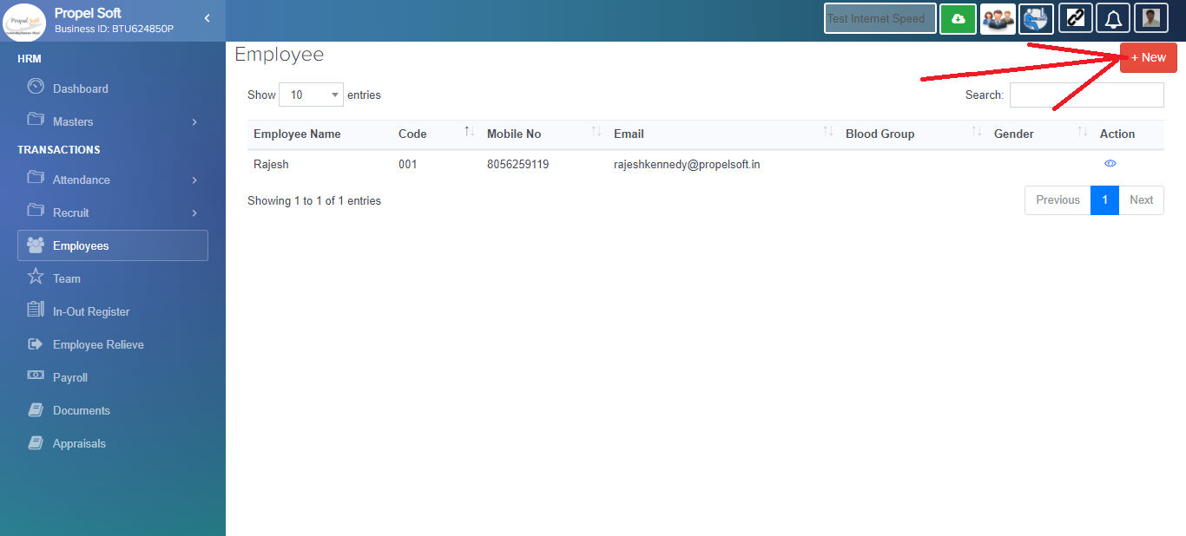

**Step-2:**

Then enter the WFM module

The side menu shown will be based on employee role provided by the admin.

i.e. - Chart View, Manage Project, Master Dataset on side menu are shown only **Admin/Manager/Owner.**

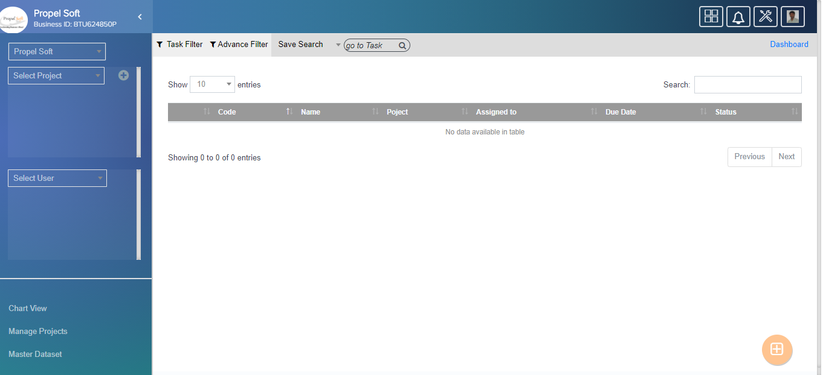above screen are showing WFM Dashboard.

Hear, on the Dashboard the task assigned to the login user (**Employee/ Admin/Manager/Owner)** are only displayed.

**Step-3:**

On prior we need a project before creating a Task. Hence create the project first by clicking add project.

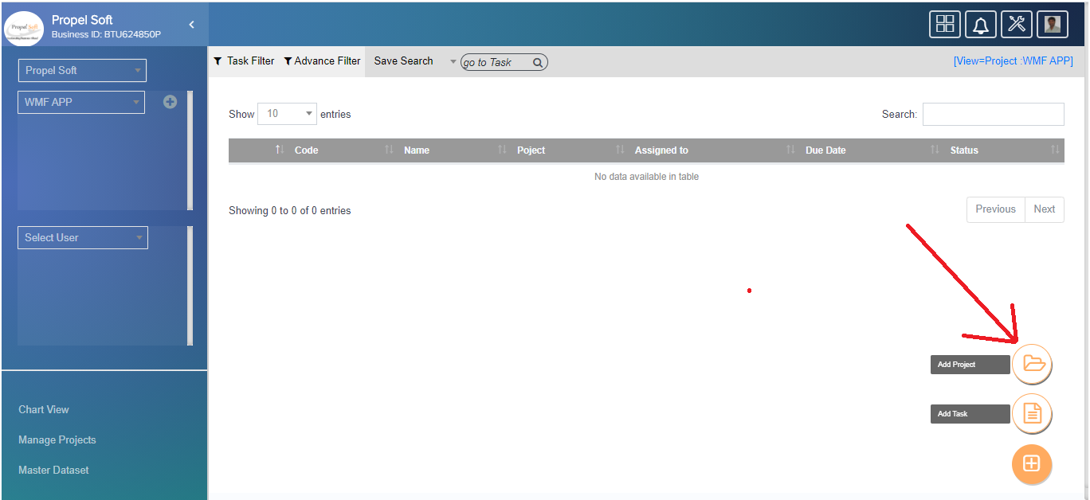

**// corrected**

here add the project, the using **Add Project popup**.

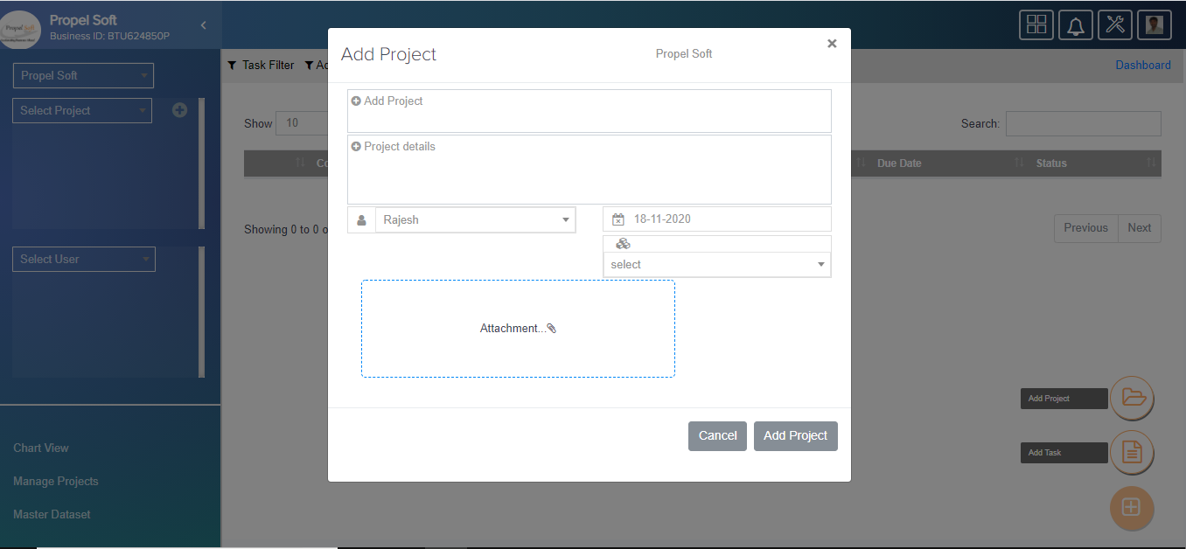

**Step-4:**

Next click the add Task.

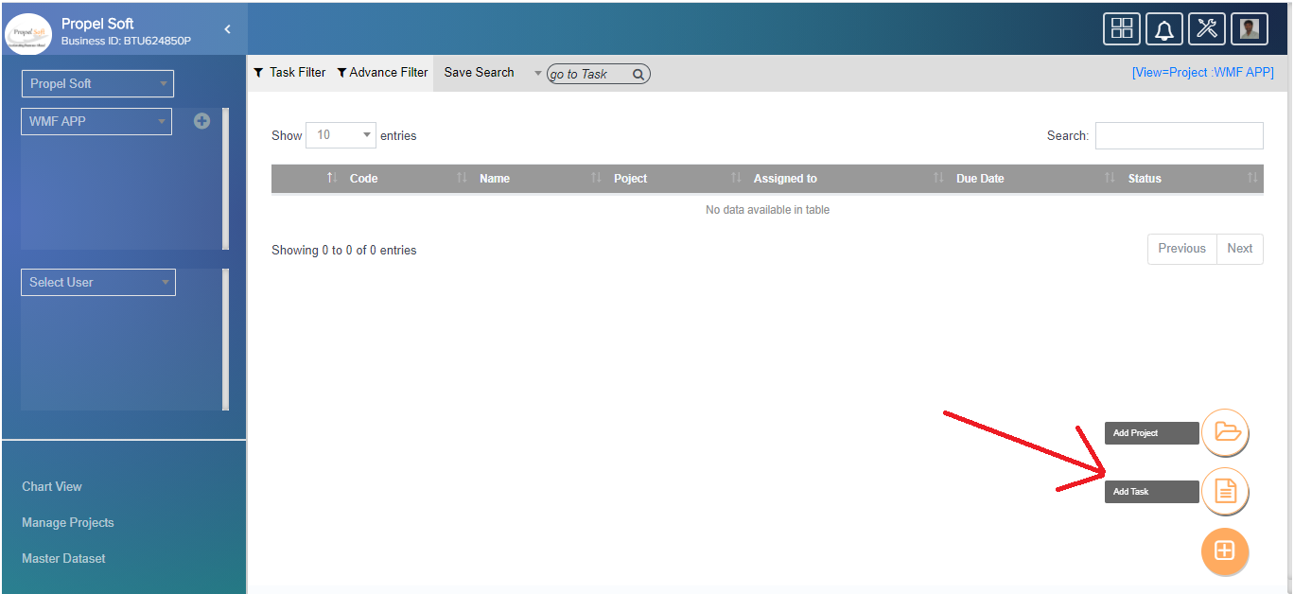

here add the Task, the using **Add Project popup**

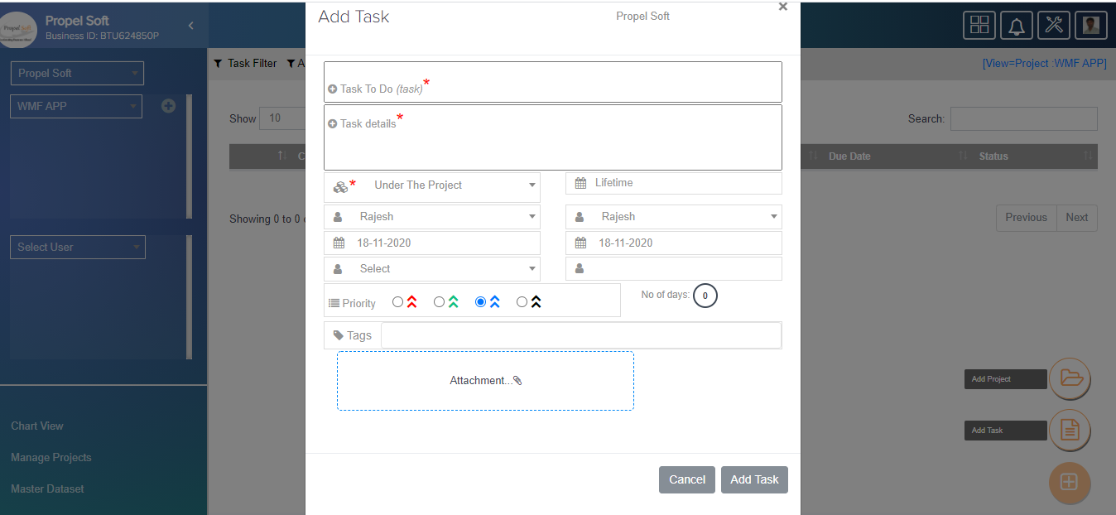---------------*****------------------

**View Task in detail:**

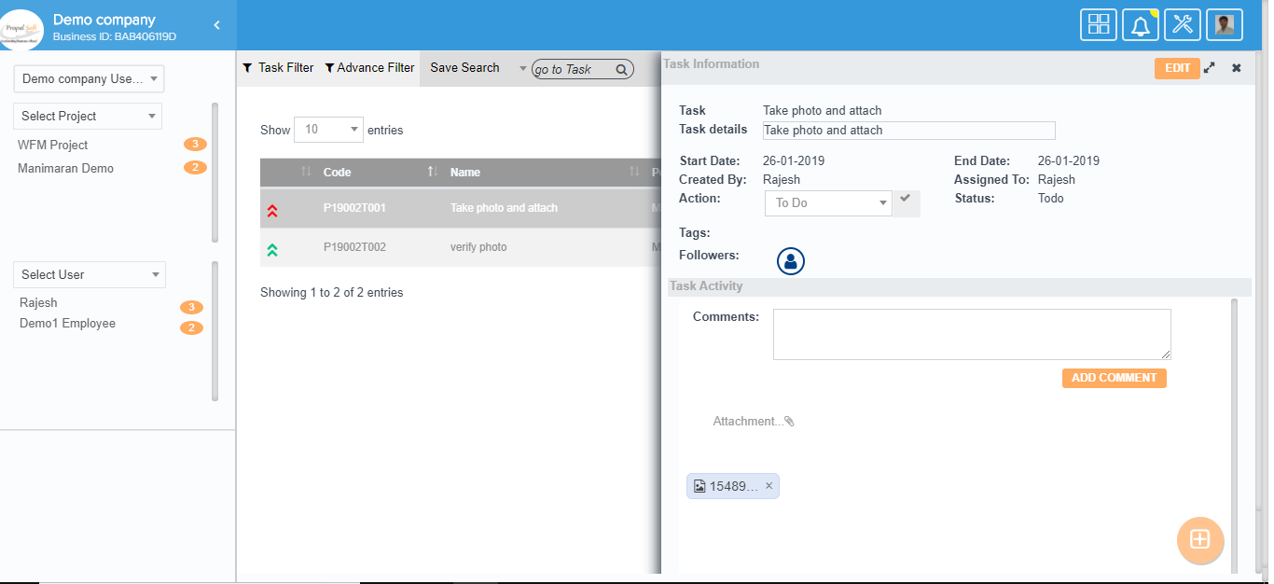To View Task in detail, click the task line. The details are shown in Popup. Where you can change action and comments.

**Edit Task:**

To edit Task, click the “Edit” Button.

**Task Filter:**

You can filter different types of work. As it all shows, it was created by me, assigned to me, following me, my highest priority, due today.

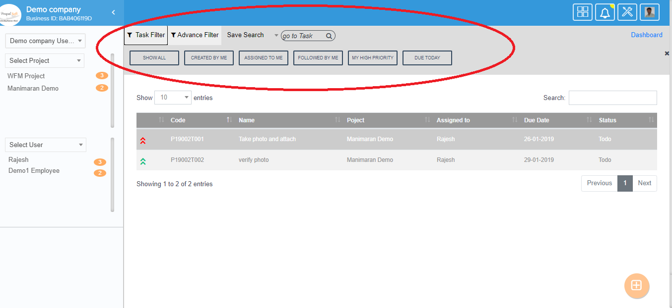

**Advance Filter:**

Can filter custom type task. Further filter results will be saved.

